NJWEA Spring Fling – 2017
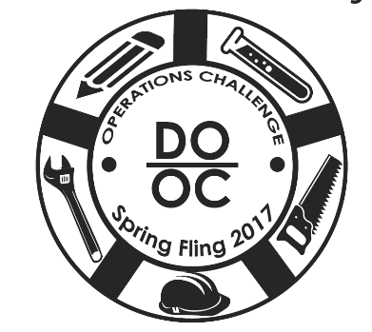
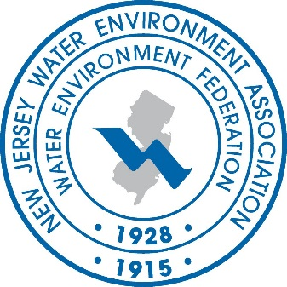
OPERATIONS CHALLENGE
Atlantic City – New Jersey
Monday, May 8, 2017
(Process, Laboratory & Wastewater Quizzo)

Tuesday, May 9, 2017
Our 11th Challenge
(Collections, Maintenance & Safety)
The NJWEA Spring Fling is the largest regional Operations Challenge Competition and has been described as a mini WEFTEC. Our goal is to mimic the Nationals! We try to bring in all the Event Coordinators, as well as using the most up to date write-ups and equipment for each event. We must be doing something right… this is our 11th Spring Fling Operations Challenge!
Entry Fee? Yes. $50.00 per team (5 members). $25.00 per person over the 5.
Event Coordinators & Judges are free!

How Many Teams? 12 Teams…Registration will open in February, and will be on a
first come first served basis! We fill up fast, don’t delay.

Conference Entry? All team members, event coordinators, judges, and family members will
be given complimentary admission into the sessions and exhibits areas
on Monday & Tuesday.

Is Food Provided? Yes. We will provide the teams (5 members), event coordinators, judges,
and support staff with breakfast (consisting of bagels & coffee), lunch and
Monday Night Hospitality reception with food & refreshments and
Tuesday Night Meet & Greet Reception (Adults Only) with an extensive
menu to choose from.
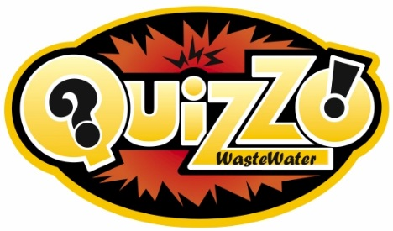 |  |  |  | Wastewater Quizzo!  It was such a hit we will be bringing it back again this year! Josh will once again host the event and we will provide beverages and snacks.
QUESTIONS/COMMENTS
Kathy Collinge, Spring Fling Coordinator
(856) 839-2683
katherinecollinge@landissewerageauthority.com
www.njwea.org

