NJWEA Battle of the Boardwalk – 2019
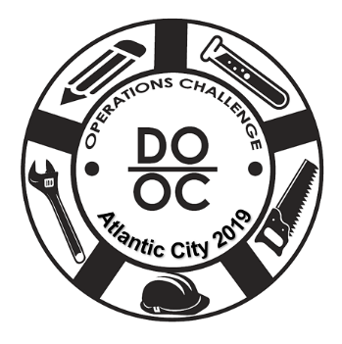
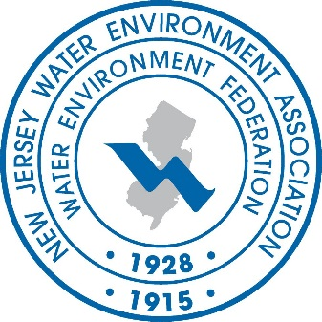
OPERATIONS CHALLENGE
Atlantic City – New Jersey
Monday, May 6, 2019
(Process, Laboratory & Wastewater Quizzo)

Tuesday, May 7, 2019
Our 13th Challenge
(Collections, Maintenance & Safety)
The NJWEA Battle of the Boardwalk is the largest regional Operations Challenge Competition and has been described as a mini WEFTEC. Our goal is to mimic the Nationals! We try to bring in all the Event Coordinators, as well as using the most up to date write-ups and equipment for each event. We must be doing something right… this is our 13th Operations Challenge!
Entry Fee? Yes. $50.00 per team (5 members). $25.00 per person over the 5.
Event Coordinators & Judges are free!

How Many Teams? 12 Teams…Registration is open, and will be on a
first come first served basis! We fill up fast, don’t delay.

Conference Entry? All team members, event coordinators, judges, and family members will
be given complimentary admission into the sessions and exhibits areas
on Monday & Tuesday.

Is Food Provided? Yes. We will provide the teams (5 members), event coordinators, judges,
and support staff with breakfast, lunch and Monday Night Hospitality
reception with food & refreshments. Including, Tuesday Night’s
Meet & Greet Reception (Adults Only) with an extensive menu to choose from.

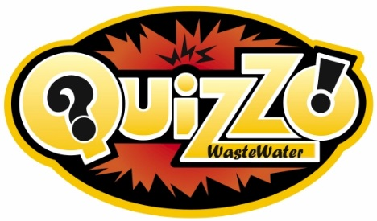 |  |  |  | Wastewater Quizzo!  It was such a hit we will be bringing it back again this year! Josh will once again host the event and we will provide beverages and snacks.
QUESTIONS/COMMENTS
Kathy Collinge, Battle of the Boardwalk Coordinator
(856) 839-2687
katherinecollinge@landissewerageauthority.com
www.njwea.org

